Form #2511 Rev. 012/2011  Submit to:  SECRETARY OF STATE  Registrations Unit  P O Box 13550  Austin, TX 78711-3550  512-475-0775  512-475-2815 – Fax  Filing Fee: None | 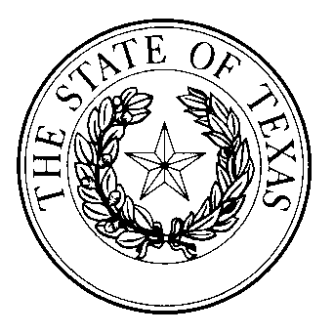  athlete agent NOTICE OF DECERTIFICATION | This space reserved for office use

This form may be used to notify the secretary of state of an agent’s decertification as an agent by a national professional sports association that has become final by the conclusion of the appeal process provided by the association. Section 2051.109, Occupations Code, requires a registered athlete agent to notify the secretary of state in writing not later than 30 days after the date of the athlete agent’s decertification. Failure to notify the secretary of state as required by § 2051.109 may be grounds for disciplinary action.

1. Name of Agent:
2. Agent ID Number: |  |  |  |  | OR |  | Registration Number:
3. Principal Business Address:
 |  | Street |  |  |  | City |  |  | State | Zip
The following national professional sports associations have decertified me as an athlete agent:
Execution
Date:
 |  |  |  | Signature of athlete agent
 |  |  |  | Printed or typed name

