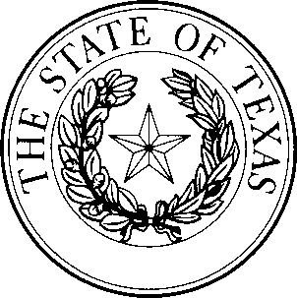
Form #2102 Rev. 11/2025

Not for use for adoption requests
(Please use Form #2103)

REQUEST FOR UNIVERSAL APOSTILLE
This space reserved for SOS use

Walk-In Service: Monday and Friday 8:30 AM – 5:00 PM
Appointment Only: Tuesday, Wednesday, and Thursday 8:30 AM – 5:00 PM

The following items are required to process a walk-in Universal Apostille request:
- Completed Form 2102: Request for Universal Apostille.
- Payment: Check, money order, or cashier check for the total amount due.
- The original Texas notarized document or certified copy of the public record requested to be apostilled.
- A prepaid and pre-addressed return envelope.
The Office of the Texas Secretary of State will not use shipping labels that state “Bill Sender” or provide no billing method with our office as the sender.

Submitter Information
Name:
Mailing Address:
Street City State Zip Code
Phone: Email Address:

Required Information
- Name of Embassy, or Country (where documents will be presented):
Apostilles cannot be presented to the United States.
- Total Number of Documents: X $15.00 = Total Amount Due

Method of Payment (Required)
Check or Money Order # Payable to the Texas Secretary of State
Payment via Credit Card is not accepted through the mail. Retain a copy of your check for reference.
Document Return Method (Tracking is highly suggested)
Self-Addressed Stamped Envelope (No Tracking)
Self-Addressed Prepaid Carrier Label (FedEx, UPS, USPS) No handwritten air-bills are accepted.
Please retain your tracking number information to track the return envelope.

Mailing Address Physical Address (for Walk-In/Appointment Services) The Office of the Texas Secretary of State The Office of the Texas Secretary of State Authentications Unit Authentications Unit
P.O. Box 13550 1019 Brazos St
Austin, TX 78711-3550 Austin, TX 78701

